1st Page:- HOME

Use below content just replace PEN REGION to KSC REGION and Replace JNPT with JNPA and keep CTA button as it is as last design (get project detail and book site visit)

Headline: INVEST IN KSC REGION THE NEXT GROWTH HUB OF MUMBAI 3.O
Sub Headline:- Be a part of the region that is set to transform with world class infrastructure, seamless connectivity & unlimited potential.
Add icon points as shown in the image below
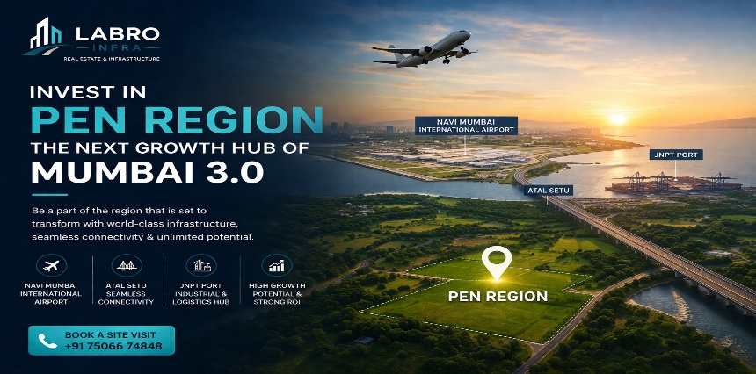

Background Image: USE ANY ONE IMAGE for background👇🏼


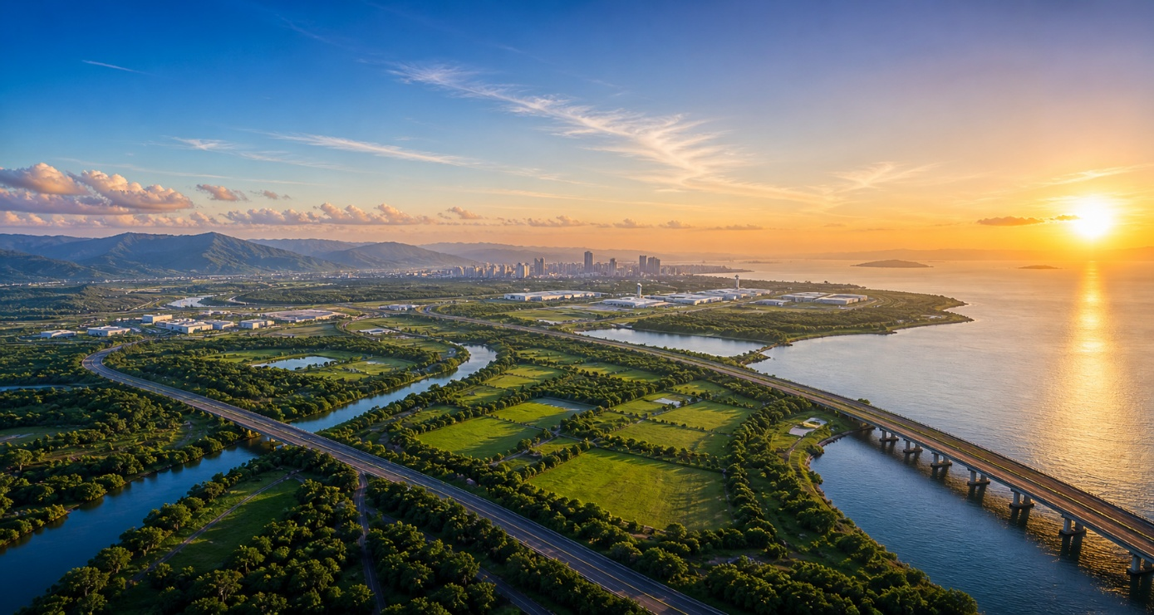

WHAT IS MUMBAI 3.O
Mumbai 3.0 refers to the Karnala–Sai–Chirner (KSC) New Town, a large-scale, government-planned urban development zone designed to become the next major growth corridor beyond Navi Mumbai.
Planned under the guidance of MMRDA, this region spans across 124 villages (~323 sq. km) and is being developed as a future-ready city driven by infrastructure, connectivity, and economic expansion.

Mumbai 3.0 is not just an expansion; it is the next phase of Mumbai’s growth.
USE KSC MAP IMAGE for What is Mumbai 3.O:- USE THIS IMAGE: 👇🏼
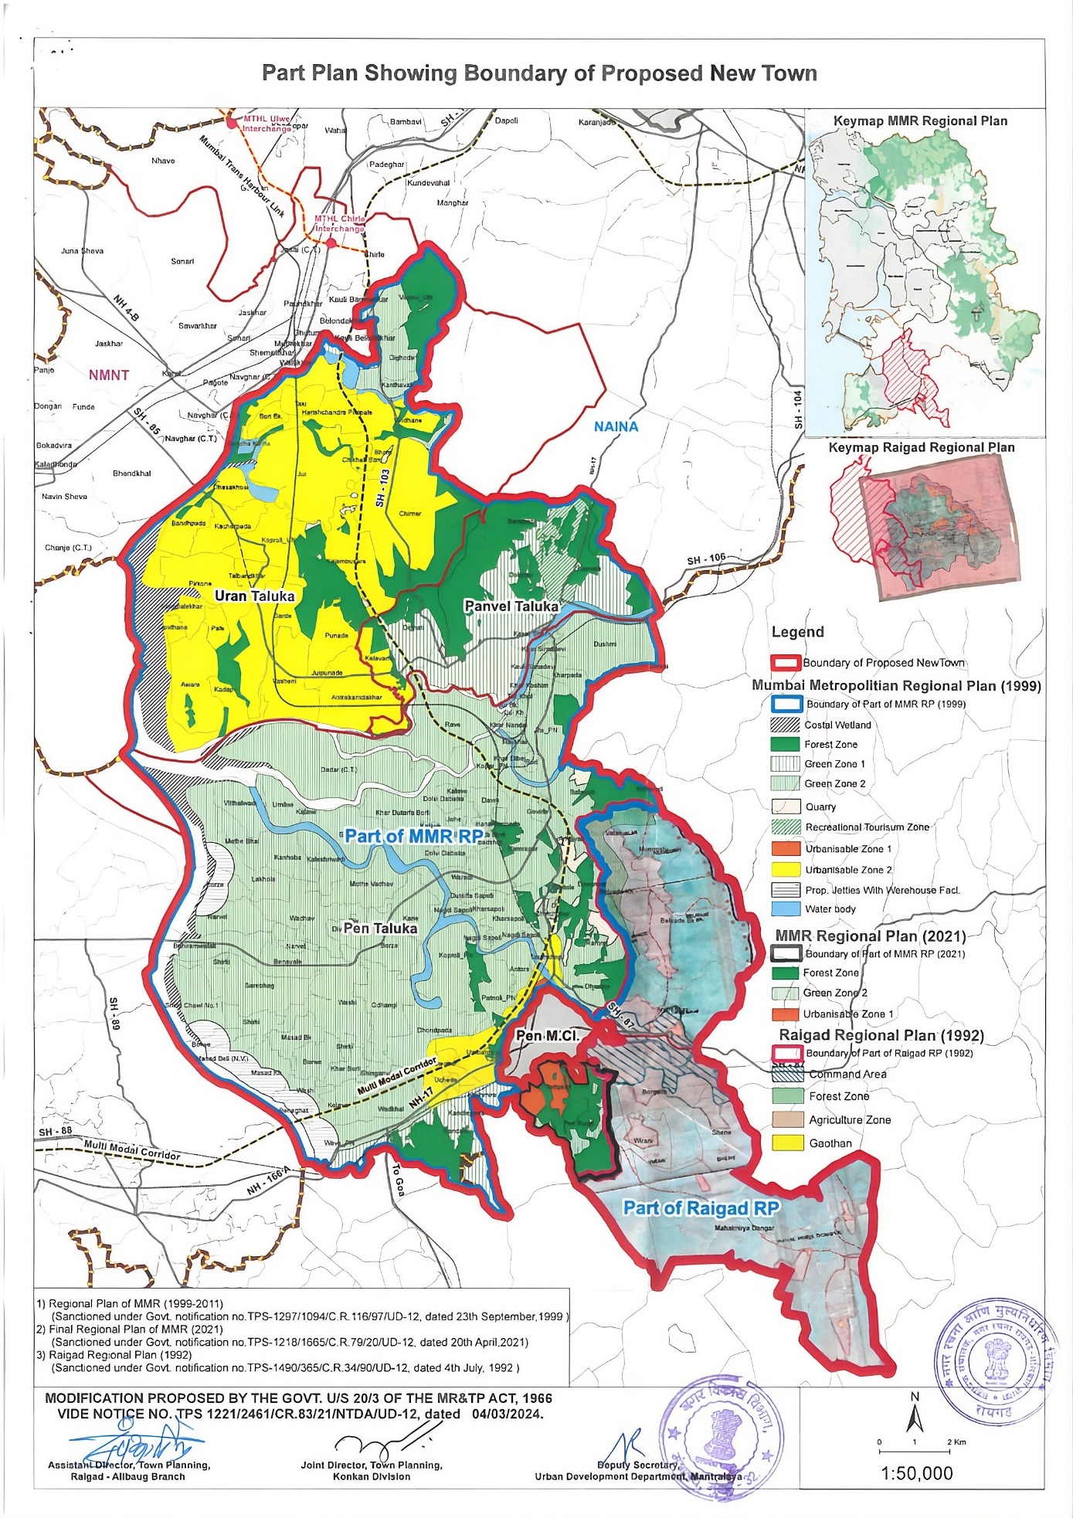
Government Vision for Mumbai 3.0
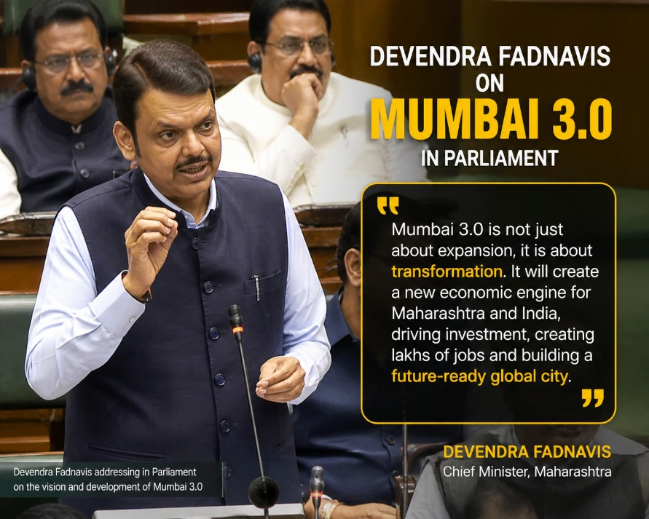
Chief Minister Devendra Fadnavis has highlighted the vision of Mumbai 3.0 as a strategic expansion of the Mumbai Metropolitan Region to support future growth. He has emphasized the need for planned development beyond Navi Mumbai, with regions like Karnala–Sai–Chirner (KSC) being developed with strong infrastructure, connectivity, and economic potential. This initiative aims to reduce pressure on existing cities while creating new opportunities for residential, industrial, and commercial growth.
Use this image for (Government Vision for Mumbai 3.O):- 👇🏼

MMRDA – Government Authority Behind Development
The Mumbai Metropolitan Region Development Authority (MMRDA) is the key government body responsible for planning and developing major infrastructure and urban growth across the Mumbai Metropolitan Region, including the Mumbai 3.0 (KSC) area. Through structured planning, policy implementation, and large-scale infrastructure projects such as roads, metro networks, and connectivity corridors, MMRDA ensures organized and sustainable development. Its involvement brings long-term vision, regulatory support, and strong infrastructure backing, which helps create planned growth, increases investor confidence, and supports the transformation of regions like KSC into future-ready urban hubs.

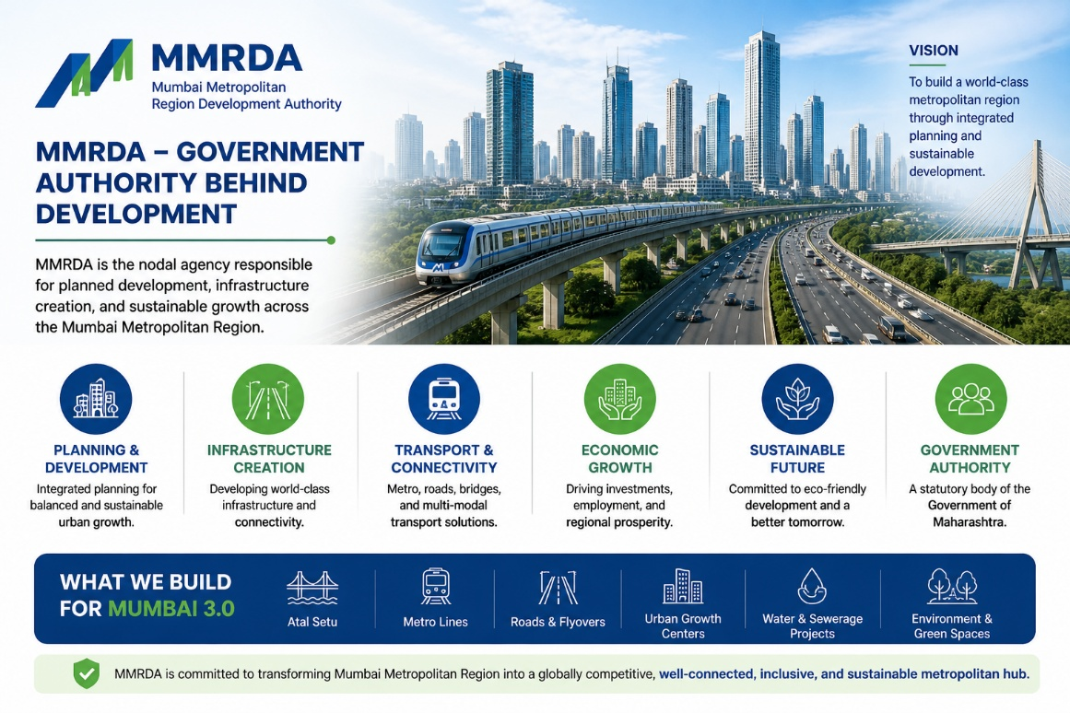
Use this Image for MMRDA – Government Authority Behind Development:- 👇🏼

Global Investors Backing Mumbai 3.0 (KSC):-
Mumbai 3.0 (KSC) has attracted strong interest from leading global and domestic investors, highlighting the region’s long-term growth potential. With strategic investments across infrastructure, data canters, and urban development, these commitments reflect growing confidence in the future of this planned expansion. Backed by government vision and large-scale infrastructure, KSC is emerging as a key destination for institutional investment.

Use this Image for Global Investors backing Mumbai 3.O (KSC): 👇🏼
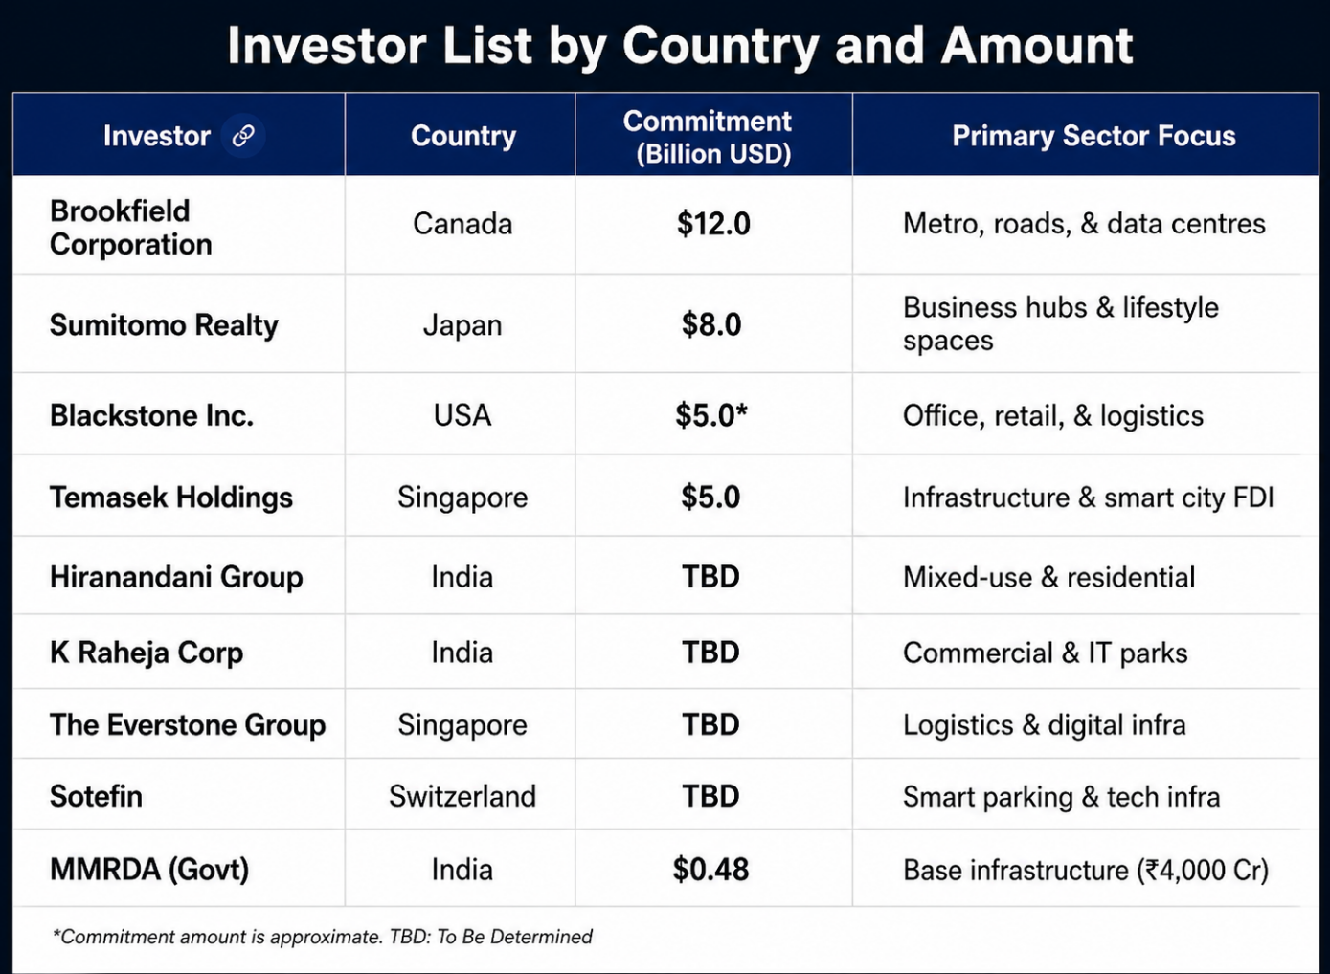

Total Project Estimates Initial
Wave: Chief Minister Devendra Fadnavis estimated that the Navi Mumbai–Third Mumbai belt will initially attract investments worth ₹15 lakh crore ($180B+) as more sectors like the Edu-city, Sports-city, and Medi-city take shape.
Infrastructure Pipeline: There is a planned $100 billion infrastructure pipeline to support the region, including the Atal Setu (MTHL) influence area.

News & Reports
Hindustan Times
https://www.hindustantimes.com/cities/mumbai-news/mmrda-to-replicate-cidco-s-and-midc-s-land-acquisition-framework-for-third-mumbai-101761244226573.html

The Indian Express
https://indianexpress.com/article/cities/mumbai/third-mumbai-land-acquisition-mmrda-projectvillagers-consent-sought-10643280/

Times of India
https://timesofindia.indiatimes.com/city/mumbai/mmrda-takes-lead-in-developing-third-mumbai-as-new-town-development-authority/articleshow/114435923.cms

News18
https://www.news18.com/cities/mumbai-news/do-you-know-third-mumbai-where-is-it-why-is-it-in-the-news-the-infra-plans-explained-ws-kl-9675379.html

2nd Page:- WHY INVEST IN KSC
WHY INVEST IN KSC (MUMBAI 3.0)?
Karnala–Sai–Chirner (KSC) is part of the Mumbai 3.0 vision, a government planned expansion designed to support future growth of the Mumbai Metropolitan Region. With strong infrastructure, strategic location, and early-stage pricing, KSC offers a powerful opportunity for long-term investors.

1. CONNECTIVITY
The KSC (Mumbai 3.0) region offers excellent connectivity, making it a strategically important location for future growth. It is well-connected to key infrastructure such as the Navi Mumbai International Airport, Atal Setu (Mumbai Trans Harbour Link), JNPA Port, and major highways linking Mumbai and Pune. This seamless connectivity not only improves accessibility but also plays a crucial role in driving real estate demand, industrial growth, and long-term value appreciation in the region.
use this image for Connectivity 👇🏼
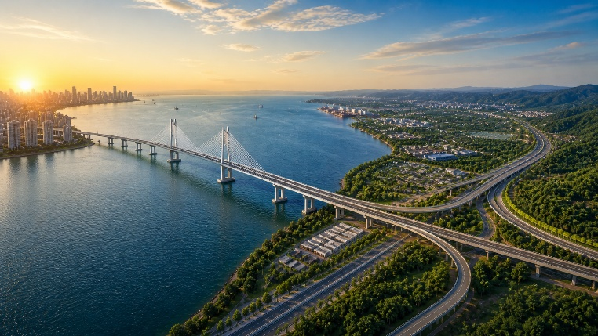

- Atal Setu (MTHL) – directly linking Mumbai to key growth zones like the airport, port, and KSC region
- Navi Mumbai International Airport – Global connectivity
- JNPA Port – India’s largest port access
- Mumbai–Pune Expressway – Seamless regional travel
- Mumbai–Goa Highway – Strong intercity connectivity
- Metro & Rail Network – Future-ready public transport
- Virar–Alibaug Corridor – Multi-modal connectivity
- Water Transport – Ferry & coastal connectivity

2. MEGA INFRASTRUCTURE DEVELOPMENT
- Next-Generation, Master-Planned Integrated City Mode:-
The KSC (Mumbai 3.0) region is being developed as a next-generation, master-planned integrated city designed for future-ready living and investment. With a strong focus on large-scale infrastructure, the region is witnessing the development of modern road networks, seamless connectivity corridors, smart urban planning, and essential utilities. This integrated approach ensures a balanced ecosystem of residential, commercial, industrial, and social infrastructure. Backed by government vision and strategic planning, the development is aimed at creating a sustainable, well-connected, and high-growth urban destination for the future.
use this image 👇🏼


- Industrial & Economic Hub:- The KSC (Mumbai 3.0) region is emerging as a major industrial and economic hub, driven by its strategic location and strong infrastructure development. With close proximity to JNPA Port, major highways, and upcoming logistics corridors, the region is well-positioned to support manufacturing, warehousing, and trade activities. The presence of industrial zones, business parks, and growing commercial developments is attracting both domestic and international investments. This rapid economic activity is expected to generate employment, boost regional growth, and create long-term opportunities for investors and businesses alike.
use this image 👇🏼
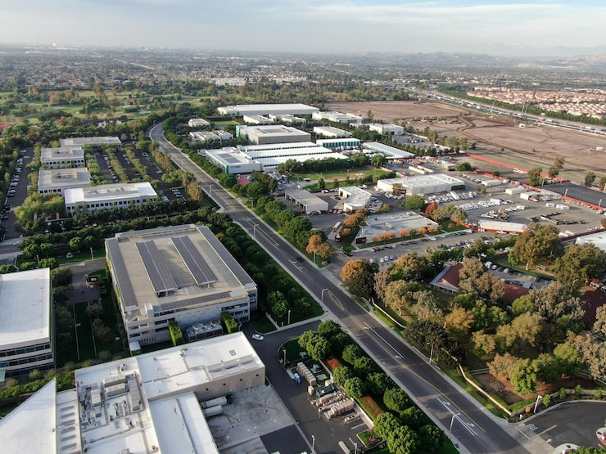

- Township & Housing Development:-
The KSC (Mumbai 3.0) region is set to witness large-scale township and housing development designed around a modern, master-planned approach. With integrated residential communities, the focus is on creating well-balanced living spaces that include essential amenities such as schools, healthcare, retail zones, and recreational areas. These developments aim to provide a high quality of life while supporting the growing demand from working professionals and families moving towards emerging growth corridors. Backed by strong infrastructure and connectivity, the region offers excellent potential for long-term residential growth and investment.
use this image 👇🏼
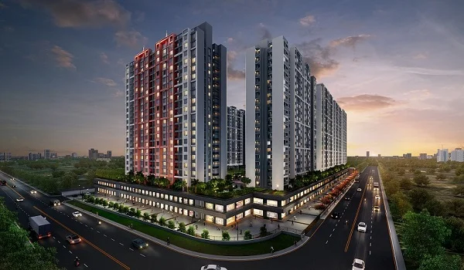

- Business & Commercial Zones:- The KSC (Mumbai 3.0) region is rapidly evolving into a vibrant hub for business and commercial activity. Planned developments include modern office spaces, IT parks, retail centers, and mixed-use commercial districts designed to support a growing corporate ecosystem. With strong connectivity to key infrastructure such as the Navi Mumbai International Airport, JNPA Port, and major highways, the region offers an ideal environment for businesses to expand and thrive. These commercial zones are expected to attract startups, enterprises, and global companies, driving economic growth and creating new employment opportunities.
use this image 👇🏼
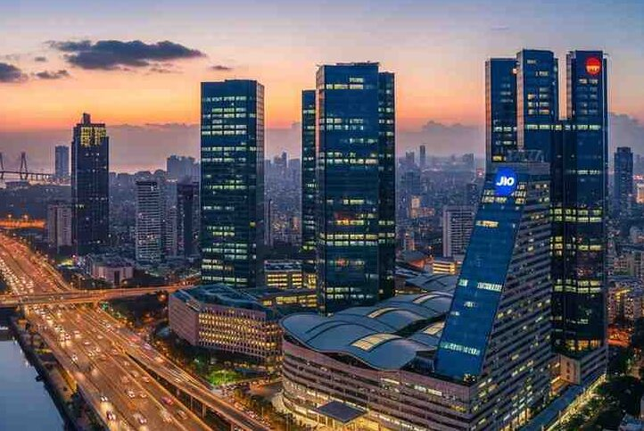

- Future Timeline:- The development of the KSC (Mumbai 3.0) region is planned in a phased and structured manner to ensure sustainable and long-term growth. In the initial phase, focus is placed on land planning, policy implementation, and key infrastructure development such as road networks and connectivity corridors. The mid-phase will witness rapid expansion through industrial zones, residential townships, and commercial developments, supported by increasing investor participation. In the long-term phase, the region is expected to evolve into a fully integrated urban ecosystem with advanced infrastructure, economic hubs, and a self-sustained city model. This phased timeline ensures steady growth, rising demand, and strong investment potential over the coming years.
use this image 👇🏼
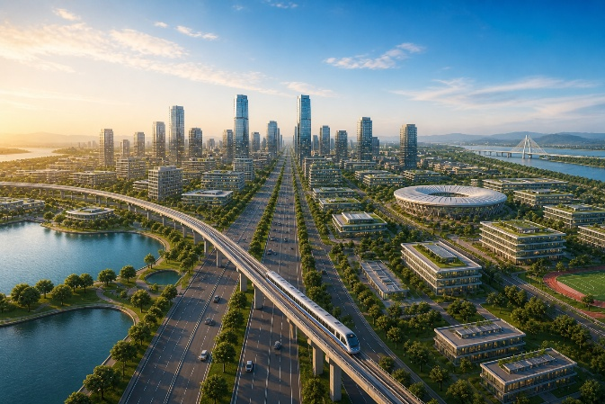

- Government Investment (Strong Signal):- Government investment in the KSC (Mumbai 3.0) region acts as a strong signal of long-term growth and development. Significant funding is being directed towards infrastructure, connectivity, and urban planning through authorities like MMRDA and the Maharashtra government. Large-scale investments in projects such as roads, transport corridors, and supporting infrastructure demonstrate clear commitment to transforming the region into a major economic hub. This early-stage government involvement not only reduces investment risk but also builds confidence among private and global investors, making KSC a promising destination for future growth and opportunities.
use this image 👇🏼
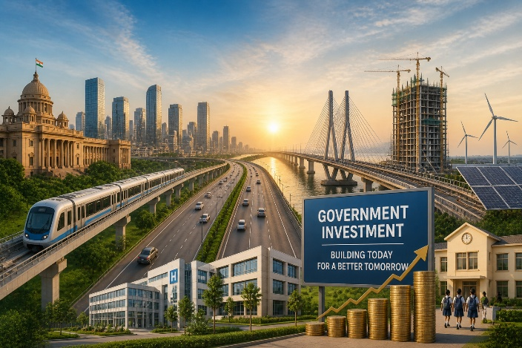

3. FUTURE CITY VISION
A fully planned, self-sustained city combining living, working, education, healthcare, and business in one integrated ecosystem.
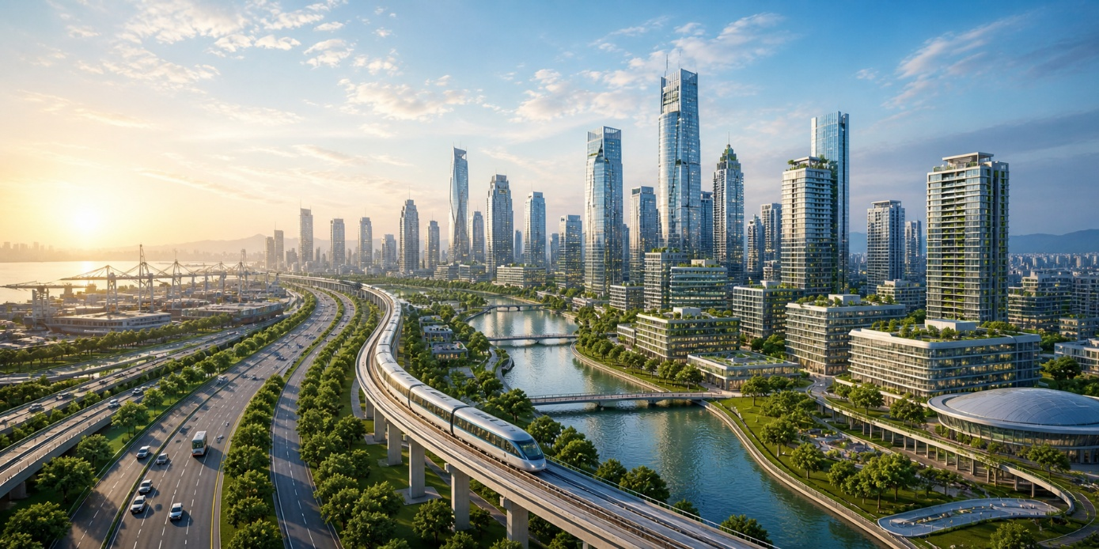

Integrated Urban Development
- Planned Residential Townships & Smart Living Spaces:- As development progresses in the KSC (Mumbai 3.0) region, it is expected that well-known real estate developers will gradually enter the market. With large land availability and improving infrastructure, the region has strong potential for planned residential townships and modern living spaces. These developments are likely to offer everything needed for comfortable living—such as schools, healthcare, daily conveniences, and open spaces. Over time, as connectivity and growth increase, the presence of reputed developers will naturally boost confidence in the region and support steady long-term growth.
use this image 👇🏼
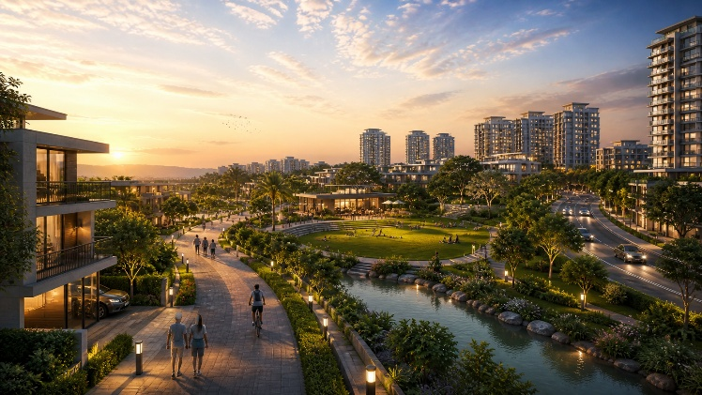

- Business Districts & IT Parks (Next BKC Potential):- As the KSC (Mumbai 3.0) region develops, it is likely to see the gradual growth of business districts and IT parks. With improving connectivity and available land, companies may start exploring this region for offices and commercial spaces. Similar to how areas like BKC developed over time, KSC has the potential to grow into an important business zone. As more businesses and startups move in, it can create job opportunities, increase activity in the area, and support overall development in the long run.
use this image 👇🏼
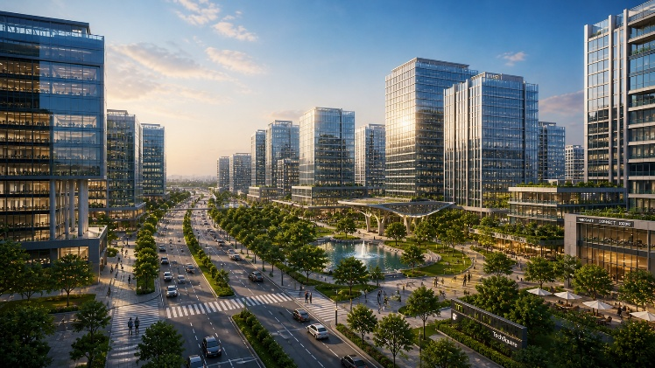

- Edu City & Med City (Education & Healthcare Hubs): As the KSC (Mumbai 3.0) region grows, it is expected that strong education and healthcare facilities will develop over time. With government planning and support under Mumbai 3.0, the region is being positioned to attract reputed institutions, hospital chains, and private investors in the education and healthcare sector. This may include schools, colleges, training institutes, hospitals, and medical centers to support the growing population.
For residents, this means better access to quality education and healthcare close to home, reducing the need to travel to Mumbai or Navi Mumbai. Over time, the presence of these essential services will improve daily life, increase demand for residential properties, and make the region more attractive for long-term living and investment.
use this image 👇🏼
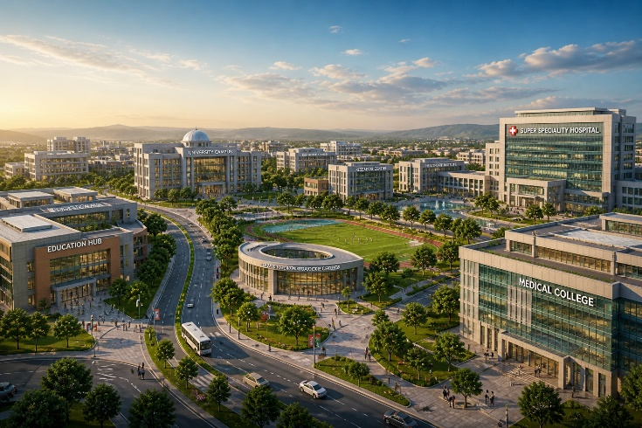

- Logistics & Industrial Zones (Driven by JNPA & Airport): As the KSC (Mumbai 3.0) region develops, it is expected to see steady growth in logistics and industrial activity due to its proximity to JNPA Port and the upcoming Navi Mumbai International Airport. With strong government planning and infrastructure support, the region is likely to attract logistics companies, warehousing hubs, and industrial investments over time.
This will improve the movement of goods, create job opportunities, and bring more business activity to the area. As industries and logistics operations grow, it will also increase demand for land and housing nearby, supporting overall development and long-term investment potential.
use this image 👇🏼
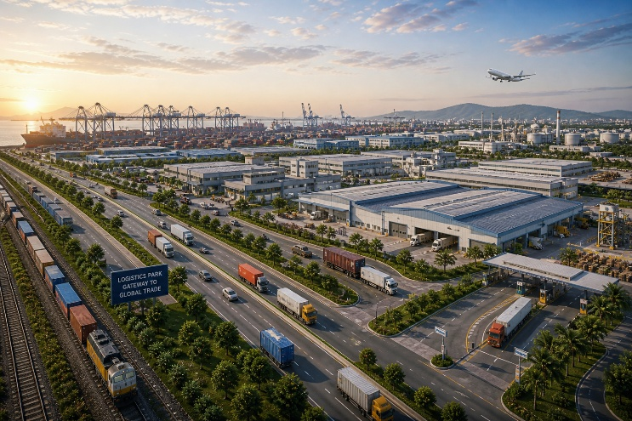

- Sports City & Entertainment Zones: As the KSC (Mumbai 3.0) region develops, it is expected that sports and entertainment facilities will gradually come up as part of the overall planning. With government support and growing interest from private investors, the area may see development of stadiums, sports academies, indoor complexes, and entertainment zones.
These facilities will not only promote a better lifestyle but also create opportunities for events, recreation, and tourism. Over time, this will make the region more vibrant and attractive for families, while also supporting local business growth and increasing the overall value of the area.
use this image 👇🏼
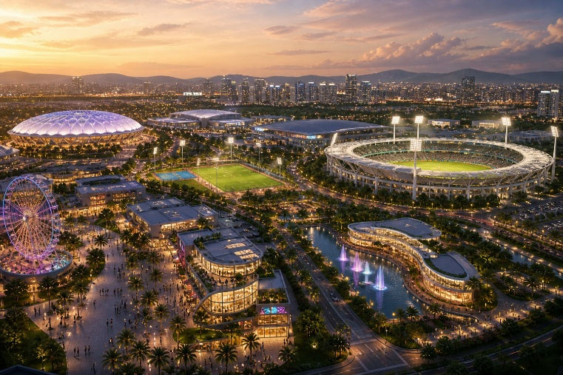

- Sustainable & Future-Ready Infrastructure: - As the KSC (Mumbai 3.0) region develops, the focus is on building infrastructure that supports long-term growth in a practical and balanced way. With proper planning from the government, the area is expected to have good road networks, reliable basic services, and systems that make daily life smoother.
Along with this, attention is also being given to cleaner and more efficient development, so that the region grows without putting too much pressure on the environment. Over time, this kind of planning will make the area more comfortable to live in and help maintain steady, long-term value.
use this image 👇🏼
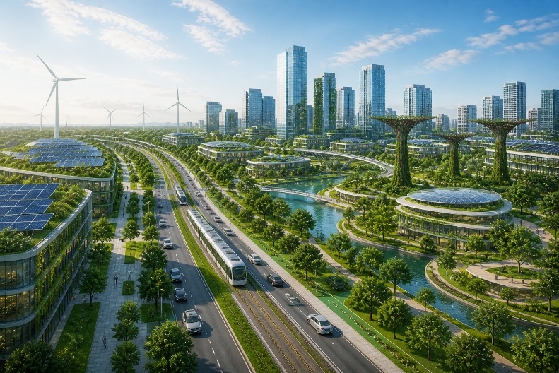

4. Early Entry Opportunity
- Lowest price stage today
- Maximum future appreciation potential

5. How do we help Invest?
1. Right Location Selection
We help you identify high-growth locations in Pen region based on upcoming infrastructure, connectivity, and future development potential.

2. Verified & Clear Title Plots
All properties are legally verified with clear documentation, ensuring safe and secure investment.

3. End-to-End Support
From site visit to final registration, we guide you at every step making the process smooth and hassle-free.

4. High Growth Investment Guidance
We don’t just sell land we help you invest in locations with strong appreciation potential.

5. Site Visit Assistance
We arrange on-ground site visits, so you can see the location, connectivity, and surroundings before investing.

6. Transparent Pricing
No hidden charges. We provide clear pricing and a complete cost breakdown.

7. Long-Term Investment Support
We stay connected even after purchase, guiding you for future resale or development opportunities.

3rd Page:- Government Support

The government is actively supporting investors through flexible land policies, infrastructure-first development, FSI/TDR benefits, and global investment promotion, making Mumbai 3.0 a structured, low-risk, and high-growth investment opportunity.


Strong Policy & Planning Support
- Planned under MMRDA (Government Authority)
- Officially declared New Town (KSC Region)
- 124 villages (~323 sq. km) under development
- Structured master planning & zoning
- Policy-driven and regulated growth

Infrastructure & Investment Push
- ₹4000+ Crore government investment
- Focus on roads, metro, airport & connectivity
- Public–private participation encouraged
- Long-term development vision

Key Policies for Investors
1. Flexible Land Acquisition Model
The government is not forcing land acquisition. Instead, investors and landowners get multiple options like:
- Direct purchase
- Compensation in FSI / TDR / monetary benefits

2. Land Pooling & Return Policy (22.5% Return Model)
Under this policy:
- Landowners can give land for development
- Government returns developed land (around 22.5%)

3. Pass-Through Policy (Investor Friendly Cost Model)
Infrastructure cost like:
- Roads
- Utilities
- Development cost

4. FSI & TDR Benefits
Government is allowing:
- Additional FSI (Floor Space Index)
- TDR usage for development

5. Foreign Direct Investment (FDI) Promotion
Government is actively attracting global investors:
- Minimum land requirement (~100 acres) for large projects
- Investment benchmark (~₹250 Cr+)

6. SPV Model (Special Purpose Vehicle)
Government allows:
- Creation of SPV (Special Purpose Vehicle) for projects

7. Infrastructure-Led Development Model
Government will first develop:
- Roads
- Connectivity
- Basic infrastructure

8. No Immediate Financial Burden on Government
- Development is designed with self-sustainable revenue model
- MMRDA handles structured funding

9. Clear Authority & Planning (MMRDA + NTDA)
Development under:
- MMRDA
- New Town Development Authority (NTDA)

CTA Button:- Check GR (redirect to:- New Town Development Authority (NTDA) | Mumbai Metropolitan Region Development Authority)
CTA Button: Check notification (redirect to: New Town Development Authority (NTDA) | Mumbai Metropolitan Region Development Authority)

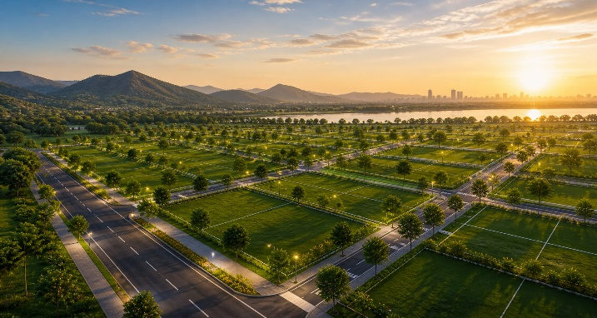
4th page:- Projects / Investment Opportunities

Headline
Premium Land Investment Opportunities in Mumbai 3.0 (KSC)
Sub Heading
Secure your position in the next major growth corridor before prices rise.

About the Opportunity
We have a strong on-ground presence in the Pen region, with deep local understanding and active project involvement. Our team ensures smooth coordination, quick execution, and efficient handling of every process. This allows us to deliver faster progress and reliable results for our clients.

PROJECT DETAILS

- Location: Pen (KSC), Navi Mumbai Extension
- Property Type: Land / Plot Investment
- Ownership: Clear Title & Verified Documents
- Land Use: Investment / Future Development Potential
- Connectivity: Close to Airport, Atal Setu, JNPA & Highways
- Accessibility: Well-connected internal & external roads
- Development Status: Early-stage (high growth potential)
- Infrastructure: Upcoming metro, roads, industrial & commercial hubs
- Investment Type: Long-term capital appreciation
- Site Visit: Available on request

Location Advantage
- Distance from Atal Setu
- Navi Mumbai Airport proximity
- JNPA Port connectivity
- Major highways
Add this image:
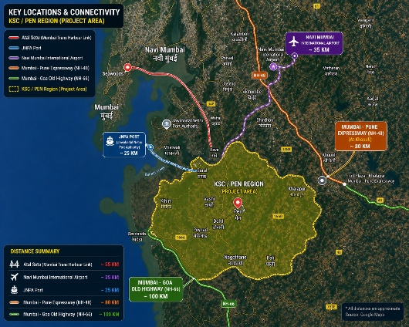
CTA Buttons:
Get Project Details – (lead form)

5th Page:- ABOUT US

Headline: “We don’t just sell land we help you invest in the future.”

Labro Infra is a forward-thinking real estate and land investment company focused on identifying high-growth opportunities in emerging development corridors like Mumbai 3.0 (KSC Region).
With a strong on-ground presence and deep understanding of market trends, we specialize in offering strategic land investment options backed by infrastructure growth and government-led development.

OUR APPROACH
At Labro Infra, we believe that real wealth is created by entering at the right time before the market recognizes the true potential.
Our approach is driven by:
- Early-stage opportunity identification
- Thorough due diligence
- Data-backed investment insights
- Transparent and client-focused service

WHAT WE DO
- Land Investment in High-Growth Zones
- Mumbai 3.0 (KSC) Focused Opportunities
- Site Visits & Ground-Level Insights
- End-to-End Investment Assistance

OUR VISION
To become a trusted name in real estate by helping investors identify future growth corridors and build long-term wealth through smart land investments.

WHY CHOOSE LABRO INFRA
- Strong On-Ground Presence
- Early Access to Strategic Locations
- Verified & Transparent Deals
- ROI-Focused Investment Approach

Contact Number:- +91 98672 30303

Email:- Info@labroinfra@gmail.com

Office address: 1105, Shelton Cubix, Plot No- 87, Sector- 15, CBD Belapur, Navi Mumbai, 400614

6th Page:- Contact us

Get in Touch with Labro Infra
Have questions or want to explore investment opportunities in Mumbai 3.0 (KSC)? Our team is here to guide you with the right information and on-ground support.

Contact Details

• Call / WhatsApp: 7506674848
- Email: info@labroinfra.com
- Office Address:
1105, Shelton Cubix, Plot No- 87, Sector- 15, CBD Belapur, Navi Mumbai, 400614

